Student’s name | …………………………………………………….…… | Grade | 2
Subject | Computer | Week No. | 9
Lesson Title | Computer Peripherals | Unit
Worksheet No. ( 9 )

write the correct name of each part.
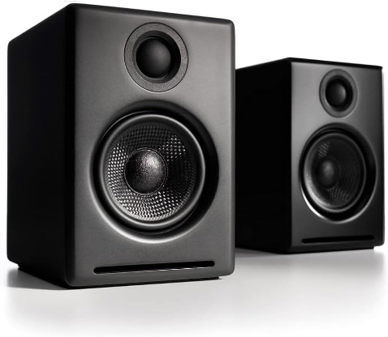
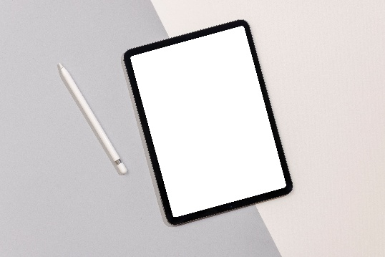
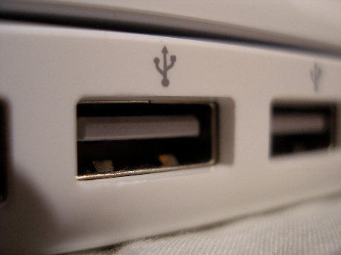
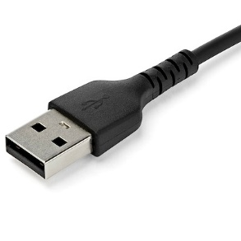
Speaker
USB Port
Pen Tablet
USB Cable
Good Luck

